Evelyn Wrench Speaker Program 2014-2015
Region VI

JONATHAN ROSE
William R. Kenan Professor History, Drew University

The Literary Churchill (with book signing)
In this lecture, based on his important new biography, The Literary Churchill: Author, Reader, Actor, Professor Jonathan Rose will introduce a Winston Churchill we have not known before and will trace the profound influence of literature and theater on Churchill’s carefully composed grand story as well as on the decisions he made throughout his political life. He will identify an array of authors who shaped Churchill’s writings and politics, from George Bernard Shaw and H. G. Wells to Margaret Mitchell, George Orwell and Oscar Wilde. Professor Rose will investigate the effect of Churchill’s passion for theater on his writing and perhaps most remarkably, he will reveal the influence of Churchill’s reading on every important episode of his public life, including his championship of social reform, plans for the Gallipoli invasion, command during the Blitz, crusade for Zionism, and efforts to prevent a nuclear arms race. Finally, he will trace the significance of Churchill’s writings to later politicians, among them President John F. Kennedy. In his recent book review for The Times, Lawrence James wrote: “Jonathan Rose… has shown how Churchill excelled in the application of language to the exercise of power and concludes that he ‘modelled his politics on literature.’ The proof is abundant and well presented in this excellent, thorough and enjoyable biography that adds a fresh and fascinating dimension to a great statesman.”

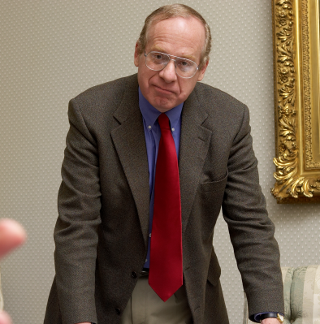
Jonathan Rose, Ph.D., is William R. Kenan Jr. Professor of History, Drew University. He received his B.A. cum laude from Princeton University and his M.A. and Ph.D. from the University of Pennsylvania. He was founding president of the Society for the History of Authorship, Reading, and Publishing and is co-editor of the journal Book History. His numerous publications include the critically acclaimed book, The Intellectual Life of the British Working Classes, named a Book of the Year (2001) by the Economist magazine. His most recent book is The Literary Churchill: Author, Reader, Actor (Yale University Press, 2014), which is garnering rave reviews. Among his many fellowships is one in 1978 from the English-Speaking Union. He lives in Morristown, New Jersey.

