National Patron Tour
Veneto, Italy
September 21 – 27, 2024

Palladio and Shakespeare in the Veneto

About the English-Speaking Union
The English-Speaking Union celebrates English as a shared language to foster global understanding and good will by providing educational and cultural programs for students, teachers, English language learners and members.

The ESU National Patron Tours
The ESU National Patron Tours enhance our Patrons’ engagement with the ESU community through bespoke experiences of cultural enrichment, educational exploration, and unforgettable adventures.

A Private View of Italy –

“I thought I’d seen Italy until I toured with Stefano who was able to open up private homes, villas and vineyards. He arranged curators and chatelaines to enlighten and entertain in a grand, yet relaxed atmosphere. His team provides the best, most intimate travel experience.”
ESU Chairman Dr. Quinn Peeper about his experience as part of the Collectors Circle of the Winterthur Museum’s Italian tour hosted by
Count Aluffi-Pentini
Our Italian Partner and Host
Founded by art historian Count Stefano Aluffi-Pentini in 1996, A Private View of Italy encourages guests to appreciate the life of historic palaces and villas, and allows them to discover the inaccessible treasures that are hidden behind closed doors. Through the centuries the Italian aristocracy has preserved their residences, which were designed by architects such as Raphael, Palladio, and Bernini.

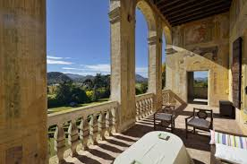
Thanks to Count Stefano Aluffi-Pentini’s trusted interactions and long-time friendships with the families owning these residences, our group will be welcomed in extraordinary places, often by the homeowners themselves.

A Private View of Italy has hosted groups from many illustrious institutions including:

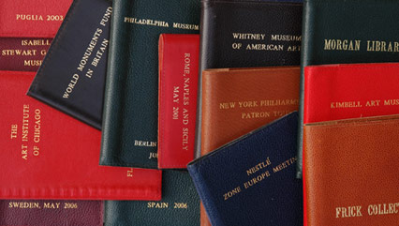
The Art Institute of Chicago
The Collectors Circle of the Winterthur Museum
The Frick Collection
Morgan Library
New York Philharmonic
The Metropolitan Museum of Art
Philadelphia Museum
Whitney Museum
World Monuments Fund

Shakespeare and the Building Arts
Shakespeare was living in a time of enormous building and re-building: great houses in London and the countryside, outdoor and indoor theaters, the Royal Exchange, ships for warfare and exploration, and his own house in Stratford-upon-Avon. The exquisite villas and palazzi of the great Italian architect Andrea Palladio influenced the design and decoration of some of these English structures. One of Palladio’s buildings, the Teatro Olimpico, helped inspire a new dramatic genre, the court masque.

This trip will allow travelers to learn more about Shakespeare’s use of Italy as a setting for many of his plays while also learning how Palladio’s principles of design influenced how buildings looked and how people thought about what they saw in the streets and in the theater. To understand the links between Shakespeare and Palladio, the trip will include visits to surviving Palladian houses and a series of lectures on Shakespeare’s plays.

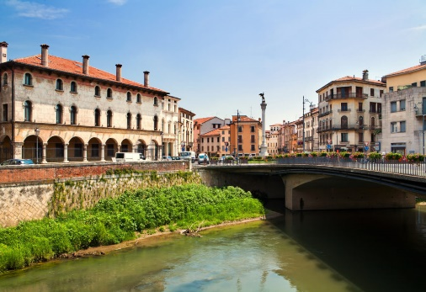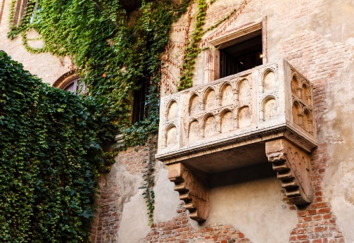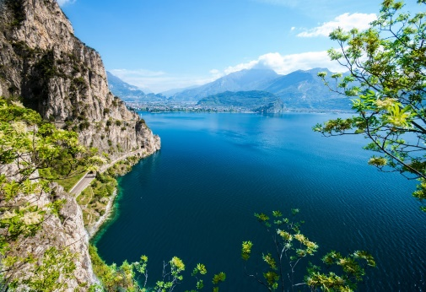

TOUR HIGHLIGHTS
(Subject to change)

Moments to Remember
MANTOVA
- Private visit to Palazzo Sordi received by Marchesa Sordi
VICENZA
- Private visit to Villa La Rotonda and its interior.
- Dinner at Villa Valmarana ai Nani received by Contessa Valmarana.
PADOVA
- Lunch at Villa Emo Capodilista in Montecchia received by Conte Giordano Emo Capodilsta

Verona
- Chiesa di San Zeno
- Chiesa di Sant’Anastasia
- Casa di Giulietta e Casa di Romeo
- Plazzo Maffei
Lake Garda & Isola de Garda
- Villa Albertini
- Villa Rizzardi
- Villa Canosa
Mantova (Mantua)
- Palazzo Ducale
- Sant’Andrea
- Palazzo Te by Giulio Romano
- Teatro Scientifico

Vicenza
- Villa La Rocca Pisana
- Villa Pisani in Lonigo
- Teatro Olimpico
- Museo Palladio e Centro Studi
- Palazzio Chiericati
Padova (Padua)
- Loggia Cornaro
- Visit to Villa Barbarigo in Valsanzibio
Asolo
- Villa Emo in Fanzolo
- Villa Barbaro by Palladio

Activity Level
There will be standing and walking for extended periods during visits to historic homes and museums or city tours. Guests should be sure-footed on stairs and able to walk at least one mile on paved and unpaved surfaces.

ITINERARY
(Subject to change)

Saturday, September 21, 2024
ARRIVAL
VERONA

* Dinner
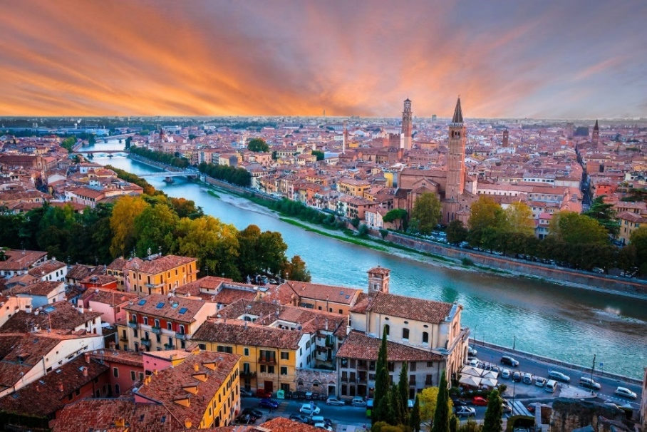
Verona, Italy

Due Torri Hotel
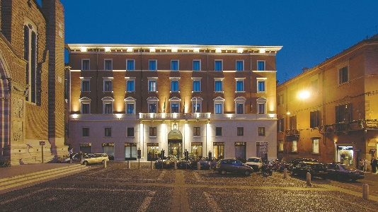
Piazza S. Anastasia, 4
37121 Verona

Located in the historic center of Verona, the Due Torri Hotel is near the ancient church of Saint Anastasia, a stone’s throw from Juliet’s famous balcony, Piazza Bra and the Arena.
The superb quality of the furnishings and the professional service are highly valued by its illustrious clientele, making it the most renowned five-star hotel in Verona.
Due Torri Hotel

Walk in Verona to see the Casa di Giulietta, the Casa di Romeo and the Tomb of Giulietta.

Chiesa di San Zeno
Constructed between 967 and 1398 AD in the Romanewque style, the Basilica di San Zeno is Its fame rests partly on its Romanesque architecture and partly upon the tradition that its crypt was the place of the marriage of Shakespeare's Romeo and Juliet.

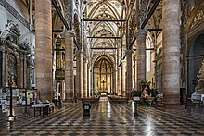
Chiesa di Sant’Anastasia
A huge church, Sant’Anastasia was begun in 1290 and built to hold the massive congregations who came to listen to the rousing sermons preached by members of the fundamentalist Dominican order. The most interesting aspect of the church is its Gothic portal, with its faded 15th-century frescoes and carved scenes from the life of St. Peter Martyr. Inside, the two holy water stoups are supported on realistic figures of beggars, known as i gobbi, the hunchbacks (the one on the left carved in 1495, the other a century later).
Chiesa Sant'Anastasia

Welcome dinner at the restaurant in Palazzo Maffei and visit to Fondazione Carlon
Started over fifty years ago, the Collection Carlon in the Palazzo Maffei, is an eclectic collection grown without chronological limits dedicated to paintings, sculptures, engravings, drawings, miniatures, old books, but also pottery, bronzes, ivories, objects of daily life such as furniture and decorative objects, from antiquity to the present day.

Sunday, September 22, 2024
VERONA - LAKE GARDA - VERONA

* Breakfast, lunch

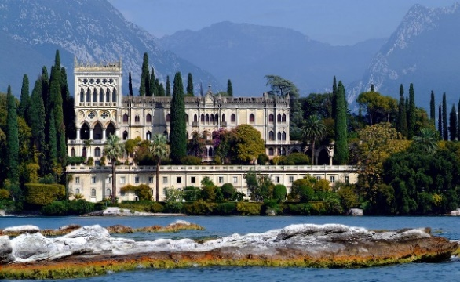
Lake Garda and Isola del Garda residence of
Conti Cavazza
The Island is situated on the Brescian side of Lake Garda, a short distance from San Felice del Benaco. The island has been visited by numerous famous figures over the centuries, reportedly including Francis of Assisi, Anthony of Padua and Dante Alighieri. Garda Island is one of the most beautiful places of Lake Garda. It is a place particularly rich in history, charm, and mysterious legends. Today it owes its fascination also to the extraordinary Venetian neo-Gothic style villa, designed by the architect Luigi Rovelli.
Isola del Garda
Departure by boat to Garda

Villa Albertini in Garda
Villa Albertini was built in the XVI century by the Becelli family, at the time owner of the coastal strip between Garda and San Vigilio. It owes its current name to the Counts Degli Albertini who became the new owners in the XVIII century and restored it some 100 years later. The park can be accessed by an avenue wondrously decorated with magnolias.

Lunch in Villa Rizzardi in Negrar
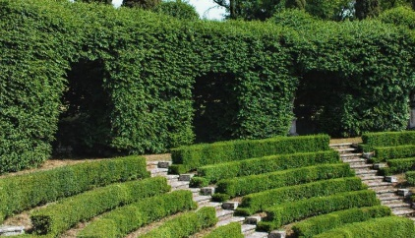
The Count Antonio Rizzardi in 1783 entrusted the design of the garden to the architect Luigi Trezza, one of the greatest proponents of Veneto’s neoclassical architecture. Mindful of the passion of his ancestors for “green” architecture and the “admired terraced garden” of Maderno sul Garda, Antonio Rizzardi created a place of spectacular scenery and impressive geometries, not so much for personal prestige as to welcome and promote new cultural trends.
Gardens at Villa Rizzardi

Lecture by Dr. Catherine Loomis

Villa Canossa
Villa Canossa built in the sixteenth century, is said to be one of the most beautiful villas on the Garda. The English Garden, for which olive trees and wines were sacrificed to make room for terracing with flowerbeds, gives it a very elegant yet untypical appearance. It belonged to the Carlotti family who, between the eighteenth and nineteenth century, expanded and transformed it into the magnificent place of now. In the second decade of the twentieth century, not having the Carlotti heirs, the villa passed to the Marquises Canossa.

Return to Verona

Dinner at leisure.

Monday, September 23, 2024
VERONA- MANTOVA-VERONA
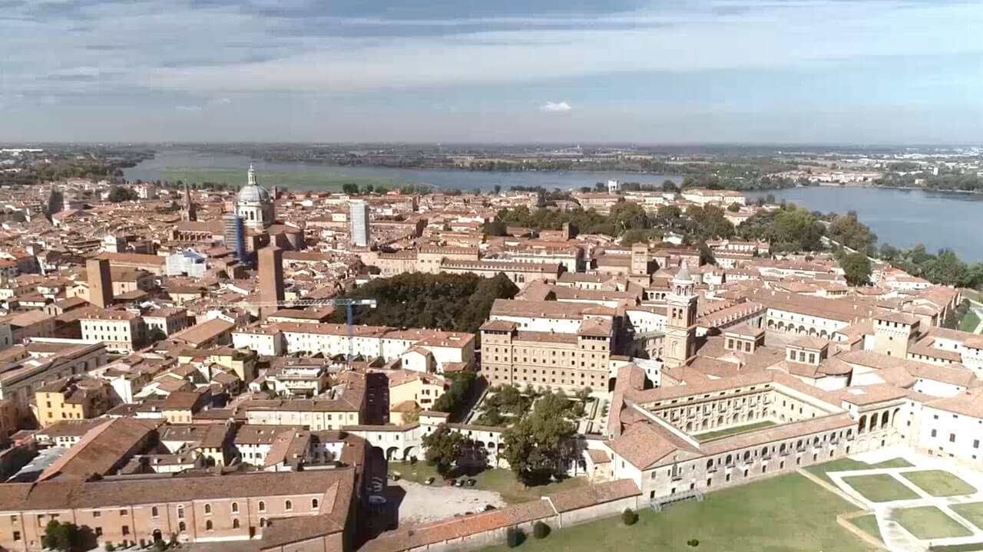
Palazzo Ducale, Mantova

* Breakfast, lunch, dinner

Depart for Mantova

Palazzo Ducale with frescos by Mantegna
The Duke’s Palace is a vast architectural complex built between the second half of the 12th century and the middle of the 17th century, as a residence as well as symbol of the power of the Gonzaga family. It is a highlight of the UNESCO site "Mantova e Sabbioneta" as an extraordinary testimony of Mantua's history, Italian Renaissance and European art between the Middle Ages and the Baroque. The whole body has about 500 rooms and extends over an area of roughly 34,000 square meters (366,000 sq.ft)

Among the masterpieces preserved into the Palace are the late-Gothic frescos by Pisanello realized at the beginning of the fifteenth century, the Camera Picta by Andrea Mantegna, one of the main examples of the Renaissance principles, and the Baroque paintings by Pieter Paul Rubens.

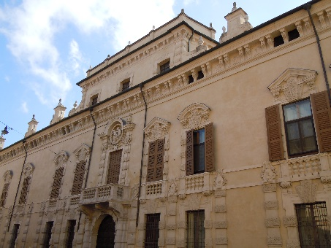
Private visit to Palazzo Sordi received by Marchesa Sordi

The Sordi Palace, built for the family of the Sordi marquises,
was built by the Flemish Frans Geffels in 1680.

Lecture by Dr. Catherine Loomis

Palazzo Sordi
Lunch in a restaurant

Sant’Andrea by Leon Battista Alberti
Designed by Leon Battista Alberti (who partially inspired to ancient models like the Basilica of Maxentius in Rome) for Ludovico II Gonzaga, it was built after his death, starting from 1472. The church, however, was finished only 328 years later. The dome (1765) and other final details were by Filippo Juvarra. The new church occupied the site of a Benedictine monastery, of which the bell tower (1414) remains.

The crypt houses the relic called Preziosissimo Sangue di Cristo (“Highly Precious Blood of Christ”), which, according to the lore, was brought to Mantua by the Roman centurion Longinus. One of the chapels houses the tomb of great painter Andrea Mantegna, with a bronze figure of him, by Gianmarco Cavalli.

Palazzo Te by Giulio Romano
Palazzo Te was built between 1525 and 1535 by Giulio Romano at the behest of Federico II Gonzaga. The famous villa, intended for parties, receptions and “ozi” of the Duke of Mantova, stood on an island in direct proximity to the city center. The rooms of the Palace - the halls of the Horses, of Love and Psyche, of the Giants - the loggias and the apartment of the Secret Garden, together with the courtyard of Honor and the garden of the Esedra represent the highest expression of Julius Roman, great architect and painter.

Teatro Scientifico del Bibiena
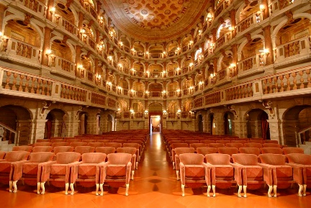
The theatre, no longer with tiers as in the Renaissance, has a bell-shaped ground plan and is laid out in orders of wood –carved theatre boxes in line with the types of structure invented in the 17th century and fashionable at the time. The classical façade was designed by Giuseppe Piermarini to whom the room on the first floor of the theatre is dedicated. It opened on 16 January 1770 by Wolfgang Amadeus Mozart. Barely 14 years old, he arrived in Mantua as part of his first Italian tour to inaugurate the splendid theatre by giving a memorable concert.

Teatro scientifico del Bibiena

Return to Verona

Dinner at a restaurant.

Tuesday, September 24, 2024
VERONA – VICENZA

* Breakfast, lunch, dinner
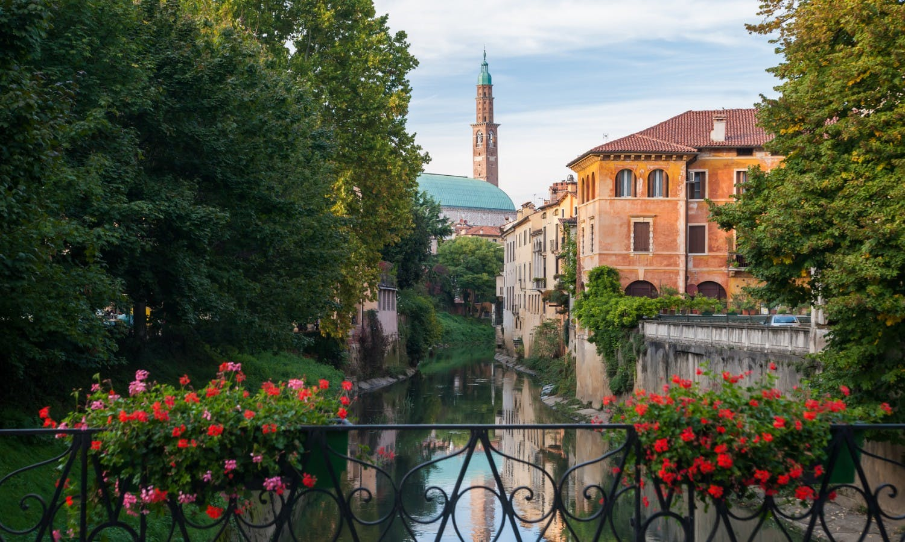
Vicenza

Travel to Vicenza

Villa La Rocca Pisana
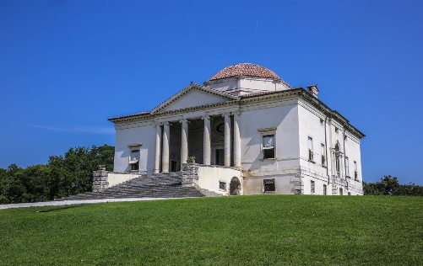
In 1576, Vettor Pisani didn’t call Andrea Palladio, who 20 years earlier had designed the Villa Pisani at Bagnolo, but approved the design of a young 28-years old architect, Vincenzo Scamozzi. This villa, the Rocca Pisana, stands out of the horizon splendid and solitary on the top of a gently rising hill. It was conceived and furnished not as a residence but as a country retreat for the pleasures of long idle afternoons and for relaxing in summer and autumn evenings.
Rocca Pisana

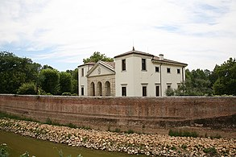
Villa Pisani in Lonigo, designed by Palladio
Another Villa of the powerful Pisani family, from 1542 on, would constitute a true turning point in Palladio’s career. In the project Palladio’s objective was an ambitious one: to create a country residence catering to the refined tastes of the Pisani brothers and at the same time capable of providing a concrete, rational organizing focus for the entire complex of agricultural annexes. In fact, Palladio succeeded in inserting the manorial block, stables, barchesse and dovecotes all within a unified design.
Villa Pisani

Teatro Olimpico

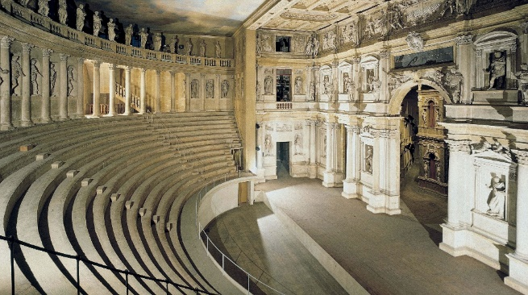
The Accademia Olimpica, established in 1555, commissioned a theatre for staging classical plays. The design by Palladio was accepted and work started just a few months before his death. It was completed by his successor Vincenzo Scamozzi.

The Teatro Olimpico is one of only three Renaissance theatres remaining in existence. It is still used several times a year. Since 1994 the Teatro Olimpico has been part of the UNESCO World Heritage Site "City of Vicenza and the Palladian Villas of the Veneto."
Teatro Olimpico

Check in Hotel Villa Michelangelo

Hotel Villa Michelangelo
Via Sacco, 35
36057 Vicenza
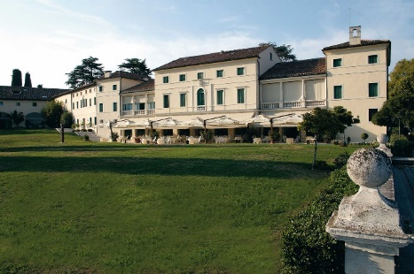
Designed in the Palladian style, Hotel Villa Michelangelo was built in the 18th century as the country house of the aristocratic Tomi family of Vicenza. In its latest incarnation, the villa is an elegant getaway for those in search of tranquility and relaxation, away from the stresses and strains of urban life.

Villa Michelangelo
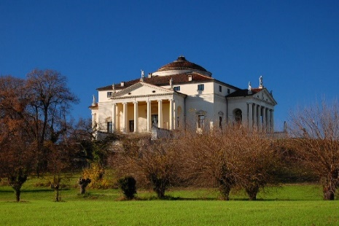

Lunch at Villa Michelangelo.

Private visit to Villa La Rotonda and its interior
Villa Almerico Capra Valmarana, or informally know as “La Rotonda,” is universally considered one of the most important works of Andrea Palladio, and of the entire Renaissance. La Rotonda is now the property of the Counts of Valmarana.
Villa La Rotonda

Dinner at Villa Valmarana ai Nani received by Contessa Valmarana

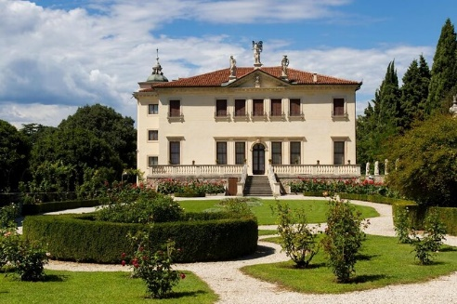
The Villa of the Counts of Valmarana was built between 1665 and 1670. It is well known for the eighteenth-century frescos of Gian Battista and Gian Domenico Tiepolo, which decorate the walls of the interior, and the perfectly conserved guest apartments that surround the Villa. The Villa itself takes its name from the bizarre sculptures of dwarfs (nani) placed on the exterior wall, a crude but expressive work by an unknown artist.
Villa Valmarana ai Nani

Wednesday, September 25, 2024
VICENZA -PADOVA-VICENZA

* Breakfast, lunch

Visit to Padova

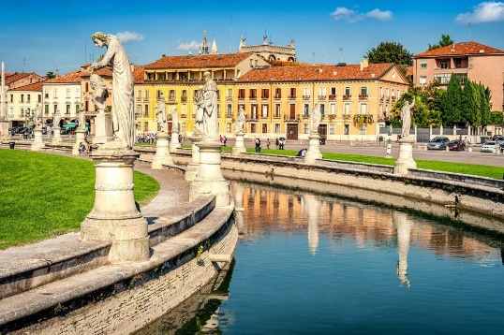
“…for the great desire I had
To see fair Padua, nursery of arts,
I am arrived…

And am to Padua come, as he that leaves
A shallow plash to plunge in the deep
And with satiety seeks to quench his thirst.”
(Act 1, Scene 1) The Taming of the Shrew

Padova

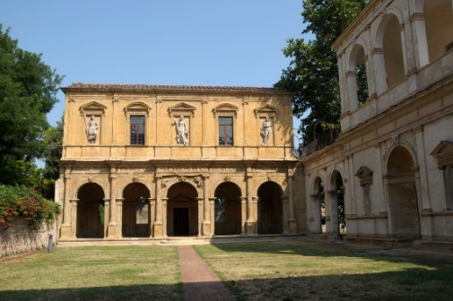
Loggia Cornaro
Built in 1524 by Alvise Cornaro and designed by the Veronese painter and architect, Giovanni Maria Falconetto, the Loggia’s sculpted and painted facade was intended as the setting for the performance of plays in a private garden setting. Traditionally considered the first classically Roman building in the Veneto, its specific designation for the performance of plays suggests the links which men like Cornaro perceived between ancient and modern theatrical practice.
Loggia Cornaro

Prato della Valle
The Prato (field) claims to be the largest public square in Italy, and its elliptical shape reflects the form of the Roman theatre that stood on the site. Saint Anthony of Padua used to preach sermons to huge crowds here, but subsequent neglect saw the area turn into a malaria-ridden swamp. The land was drained in 1767 to create the canal that now encircles the Prato. Four stone bridges cross the picturesque channel, which is lined on both sides by statues of seventy-eight eminent citizens of Padua.

Walk by Palazzo della Ragione and Piazza delle Erbe

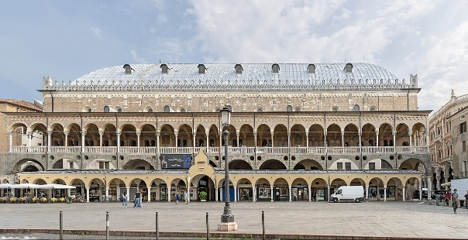
Palazzo della Ragione is a medieval market hall, town hall and palace of justice building, reputed to have the largest roof unsupported by columns in Europe.

The Palazzo was begun in 1172 and finished in 1219. In 1306, Fra Giovanni, an Augustinian friar, covered the whole building with one roof (originally there were three), spanning the three chambers into which the hall was at first divided.
Palazzo della Ragione

Cappella degli Scrovegni (time permitting)
The Scrovegni Chapel, dedicated to St. Mary of the Charity, frescoed between 1303 and 1305 by Giotto, upon the commission of Enrico degli Scrovegni, is one of the most important masterpieces of Western art. The frescoes, which narrate events in the lives of the Virgin Mary and Christ, cover the entire walls. On the wall opposite the altar is the grandiose Universal Judgement, which concludes the story of human salvation.

Lunch at Villa Emo Capodilista in Montecchia received by Conte Giordano Emo Capodilsta

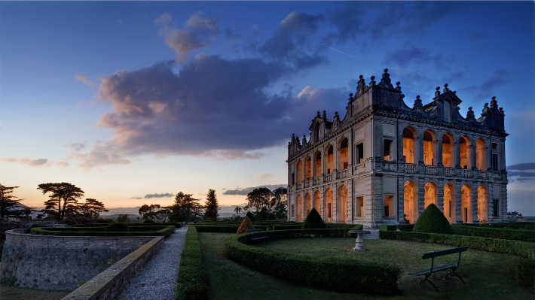
Found among the precious vineyards at Montecchia is Villa Capodilista, built in the sixteenth century to a design by Dario Varotari, whose frescoes and original architecture are among the most admired in the Villas of the Veneto.

The rooms and the loggias in the villa are embellished with “grotesque” decorations, as well as scenes and characters from Roman history and mythology. The lovely villa is surrounded by geometric gardens and, of course, the vineyards. It is still owned by the Conte Emo Capodilista.

Villa Emo Capodilista

Villa Barbarigo in Valsanzibio
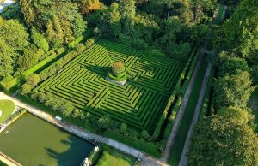
Villa Barbarigo in Valsanzibio ranges among the most important and unspoiled baroque gardens in the world. It was created in 1669 by the Venetian nobleman Zuane Francesco Barbarigo. His son Gregorio, a Cardinal and future Saint, inspired the symbolic meaning of the plan drawn by Luigi Bernini, top Vatican architect and fountain expert. Sixty full size statues, mainly work of Enrico Merengo, and sixty more different sculptures were integrated into a world of architecture, streams, fountains, water jokes and fish ponds, between hundreds of different trees and over an area of forty acres. All this was planned as an allegory of man's progress towards his own perfectibility or salvation and such itinerary ends right in front of the Villa.
Villa Barbarigo

Lecture by Dr. Catherine Loomis

Return to Vicenza

Dinner at leisure.

Thursday, September 26, 2024
VICENZA

* Breakfast, lunch, dinner

Visit to Vicenza

Museo Palladio e Centro Studi
Founded in 1958, the Centro Internazionale di Studi di Architettura Andrea Palladio is dedicated to research in the field of the history of architecture. The activities of the Centre, which are steered by a scientific committee of leading European and North American specialists, include conferences, publications and exhibitions dedicated not only to Palladio but also to aspects of architectural history, from antiquity to the modern age. The Centro's library, photo and specialized archives are open to the public. The Centre is housed in Palazzo Barbaran da Porto, one of the most beautiful of Palladio's palaces.

Walk in Vicenza

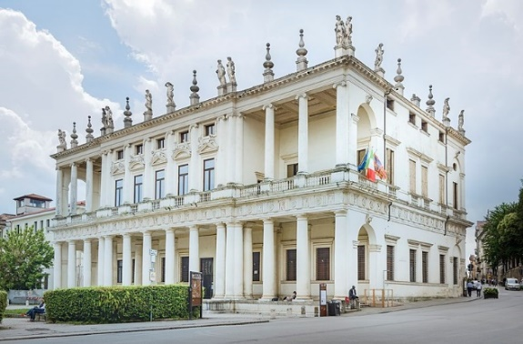
Palazzo Chiericati
This palazzo, one of Palladio's most original and interesting buildings, was begun in 1550 but work on it continued for a whole century after the architect's death, until close to the end of 1680. The façade of the building is composed of a portico on the ground floor and a piano nobile, the latter consisting of a central block - in which five windows open

Palazzo Chiericati has been the seat of the Pinacoteca Civica since 1855 and conserves various works of great artistic interest in its rich collection.

Depart for Asolo
Palazzo Chiericati

Asolo
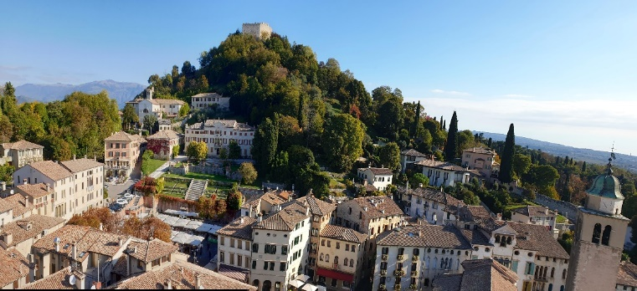
Writers, Italian and foreign poets and artists, brought by the historical events or attracted by the beauty of this place, visited and loved Asolo: from Pietro Bembo who wrote "Gli Asolani" when Asolo was run by the Queen Cornaro, to Robert Browning who dedicated "Asolando," from Giosuè Carducci who called it "la Città dai cento orizzonti" (the Town of a hundred horizons), to Ada Negri; from Igor Strawinsky to Gian Francesco Malipiero.
Asolo

Lunch in Asolo at Villa Cipriani

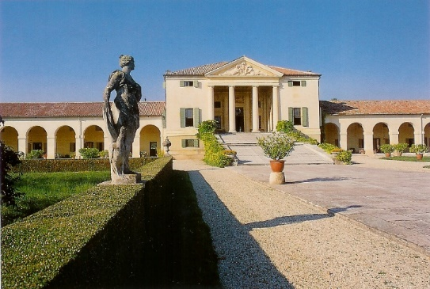
The Palladian villa as the product of a new typology — where the practical necessities of agricultural life were translated into unheralded forms and a new language inspired by ancient architecture — without doubt one finds its most definitive incarnation in the Villa Emo. At Villa Emo the buildings which functioned for the management of the estate, casually arranged around the threshing-floor of the Quattrocento villa, achieved an unforeseen architectural synthesis that united in a linear continuity the manorial house, barchesse and dove-cotes.
Villa Emo

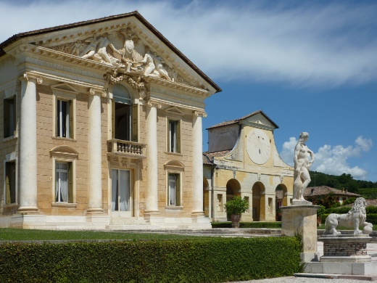
Villa Barbaro in Maser by Palladio

The Villa was built between 1550 and 1560 by Andrea Palladio for Daniele Barbaro, Patriarch of Aquileia, and his brother Marcantonio, Ambassador of the Venetian Republic, transforming the medieval palace of Maser into a splendid country residence, a masterpiece of the Venetian Renaissance. Paolo Veronese decorated the Villa with his vastest and most important cycle of frescoes, while Alessandro Vittoria, brilliant pupil of Sansovino, cured the stuccos.

Villa Barbaro
Return to the Hotel Villa Michelangelo

Dinner in a private residence.

Friday, September 27, 2024
DEPARTURE

* Breakfast

Our Shakespeare Expert

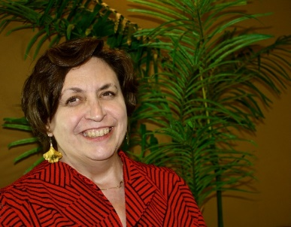
Dr. Catherine Loomis holds a PhD in Renaissance Literature from the University of Rochester, and an MA in Shakespeare and Performance from the Shakespeare Institute in Stratford-upon-Avon. From 1997 until 2017 she taught Shakespeare and other literature courses at the University of New Orleans, leaving as a tenured full professor. She has also taught at the University of North Carolina at Greensboro and at the Rochester Institute of Technology. Dr. Loomis is the author of William Shakespeare: A Documentary Volume (2002), a collection of the documents we use to construct Shakespeare’s biography, and of The Death of Elizabeth I: Remembering and Reconstructing the Virgin Queen (2010), a study of the literary response to the death of Queen Elizabeth I. With Dr. Sid Ray, she is the co-editor of Shaping Shakespeare for Performance: The Bear Stage (2015), a collection of essays on the staging practices used by Shakespeare and his contemporaries. Dr. Loomis has published numerous scholarly essays on Shakespeare and Queen Elizabeth I, and serves as president of the Queen Elizabeth I Society, a group of scholars dedicated to the study of Elizabethan history, art history, and literature.

Activity Level: There will be standing and walking for extended periods during visits to historic homes and museums or city tours. Guests should be sure-footed on stairs and able to walk at least one mile on paved and unpaved surfaces.

Tour Price

Per person, based on double occupancy in a Classic/Deluxe Room $13,900
Single supplement $815

HOTEL UPGRADE

Hotel Due Torri Upgrade from Classic to:

Deluxe $425
Grand Deluxe Room $783

Hotel Villa Michelangelo Upgrade from Superior to:
Deluxe $70
Suite $380

What is included?
- Hotel accommodation for six nights. Three nights at the Hotel Due Torri in a Classic room (5 available). When the Classic rooms are no longer available the traveler should book a Deluxe room (7 available) paying for the upgrade. Three nights at Hotel Villa Michelangelo in a Superior Room (5 available). When the Superior rooms are no longer available the travelers should book a Deluxe Room (7 available) or a Suite (3 available) paying the upgrade.
- Six breakfasts
- Lunch and dinner as mentioned in the itinerary including wine
- All transportation by minivans according to the itinerary
- All visits and private visits
- All taxes (including City Tax)
- Complete pre-departure documentation and materials including reading list, travel tips, and destination information

What is not included?
- Airfare from and to USA
- Airport porterage
- Fees relating to applying for or renewing your passport
- Transfer from the airport to the hotel at the arrival
- Transfer from the hotel to the airport at the departure
- Any kind of personal insurance
- Meals at leisure or not mentioned
- Drinks before, during and after meals
- Extra nights
- Extra costs at the hotel

